Version 1.0

Revision History

|  |  |  |  |
| --- | --- | --- | --- |
| **Date** | **Version** | **Description** | **Author** |
| 15/12/2019 | 1.0 | details | Hoang Trung Hieu |
|  |  |  |  |
|  |  |  |  |
|  |  |  |  |

Table of Contents

1. Introduction 2

1.1 Purpose 2

1.2 Scope 2

1.3 Definitions, Acronyms, and Abbreviations 2

1.4 References 2

1.5 Overview 2

2. Flow of Events—Design 2

3. Derived Requirements 2

# Introduction

## Purpose

This document describes how the Order Computers Use-Case is realized within the design model, in terms of collaborating objects

## Scope

This document applies to the Computer Shop Management System which will be developed by CT Computer

## Definitions, Acronyms, and Abbreviations

User – a person who use the system, can be customer or employee.

Employee – a person who work for the computer shop.

Guest – a user who is not logged in the system.

## References

None

## Overview

In the following section, Use-Case Realization Specification of the Order Product Use-Case of the Computer Shop Management System is provided in detail. The first section contains diagrams (sequence diagrams) describing how the use case is realized in terms of collaborating objects. The second section includes class diagrams with relationships that participate in the realization of the use case. The last section is an analysis of all requirements, such as non-functional requirements, on the use-case realization that are not considered in the design model, but that need to be taken care of during implementation.

# Flow of Events—Design

**Sequence Diagram:**

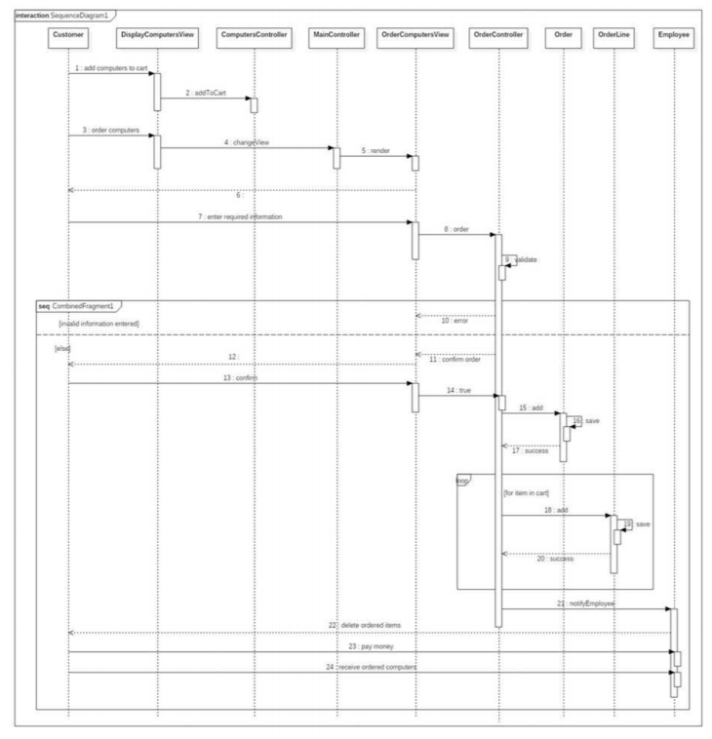

Class Diagram

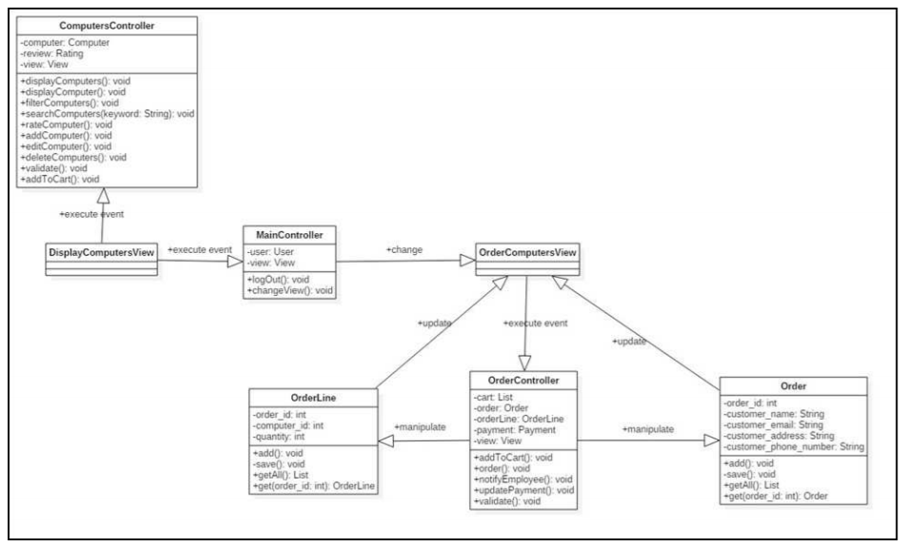

# Derived Requirements

None